Task # 01: Raising a number n to a power p is the same as multiplying n by itself p times. Write a function called power() that takes a value for n and an int value for p , and returns the result as a double value.
CODE:
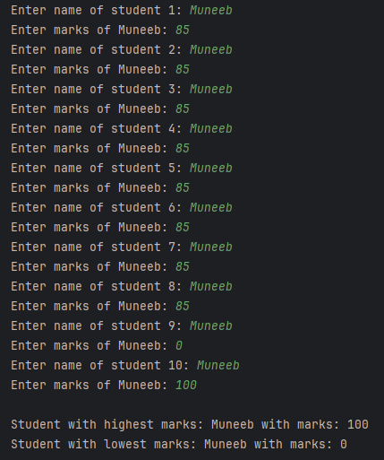
import java.util.Scanner;
public class Main {
public static void main(String[] args) {
Scanner scanner = new Scanner(System.in);
String[] names = new String[10];
int[] marks = new int[10];
// Input names and marks of 10 students
for (int i = 0; i < 10; i++) {
System.out.print("Enter name of student " + (i + 1) + ": ");
names[i] = scanner.nextLine();
System.out.print("Enter marks of " + names[i] + ": ");
marks[i] = scanner.nextInt();
scanner.nextLine(); // consume the newline character left by nextInt()
}
// Initialize variables to track highest and lowest marks
int highestMarks = marks[0];
int lowestMarks = marks[0];
String highestStudent = names[0];
String lowestStudent = names[0];
// Find the highest and lowest marks and corresponding students
for (int i = 1; i < 10; i++) {
if (marks[i] > highestMarks) {
highestMarks = marks[i];
highestStudent = names[i];
}
if (marks[i] < lowestMarks) {
lowestMarks = marks[i];
lowestStudent = names[i];
}
}
// Output the results
System.out.println("\nStudent with highest marks: " + highestStudent + " with marks: " + highestMarks);
System.out.println("Student with lowest marks: " + lowestStudent + " with marks: " + lowestMarks);
scanner.close();
}
}
Task # 02: Raising a number n to a power p is the same as multiplying n by itself p times. Write a function called power() that takes a value for n and an int value for p , and returns the result as a double value.
CODE:
import java.util.Scanner;
public class Main {
public static void main(String[] args) {
Scanner scanner = new Scanner(System.in);
System.out.print("Enter your name: ");
String name = scanner.nextLine();
name = name.toLowerCase();
int consonantCount = 0;
for (int i = 0; i < name.length(); i++) {
char ch = name.charAt(i);
if (Character.isLetter(ch) && !isVowel(ch)) {
consonantCount++;
}
}
System.out.println("Total number of consonants in your name: " + consonantCount);
scanner.close();
}
public static boolean isVowel(char ch) {
return (ch == 'a' || ch == 'e' || ch == 'i' || ch == 'o' || ch == 'u');
}
}

OUTPUT:
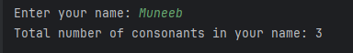

Task # 03: Raising a number n to a power p is the same as multiplying n by itself p times. Write a function called power() that takes a value for n and an int value for p , and returns the result as a double value.
CODE:
import java.util.Scanner;
public class Main {
public static void main(String[] args) {
Scanner scanner = new Scanner(System.in);
System.out.print("Enter an integer: ");
int num = scanner.nextInt();
int reversed = 0;
while (num != 0) {
int digit = num % 10;
reversed = reversed * 10 + digit;
num = num / 10;
}
System.out.println("Reversed number: " + reversed);
scanner.close();
}
}
OUTPUT:


Task # 04: Write a java program which reads a string from the keyboard and prints its words in reverse order. Following is the sample run of the program: Enter text: Welcome to Iqra University Reverse: University Iqra to Welcome.
CODE:
import java.util.Scanner;
public class Main {
public static void main(String[] args) {
Scanner scanner = new Scanner(System.in);
System.out.print("Enter an integer: ");
int num = scanner.nextInt();
int reversed = 0;
while (num != 0) {
int digit = num % 10;
reversed = reversed * 10 + digit;
num = num / 10;
}
System.out.println("Reversed number: " + reversed);
scanner.close();
}
}
OUTPUT:
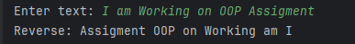

Task # 05: Creating and Populating an Array of your choice.
CODE:
public class Main {
public static void main(String[] args) {
int[] numbers = {4, 7, 2, 9, 5};
System.out.print("Array elements: ");
for (int num : numbers) {
System.out.print(num + " ");
}
System.out.println();
int sum = 0;
for (int num : numbers) {
sum += num;
}
System.out.println("Sum: " + sum);
int largest = numbers[0], smallest = numbers[0];
for (int num : numbers) {
if (num > largest) largest = num;
if (num < smallest) smallest = num;
}
System.out.println("Largest: " + largest);
System.out.println("Smallest: " + smallest);
System.out.print("Squares: ");
for (int num : numbers) {
System.out.print((num * num) + " ");
}
System.out.println();
String str = "Hello";
System.out.print("Characters: ");
for (int i = 0; i < str.length(); i++) {
System.out.print(str.charAt(i) + " ");
}
System.out.println();
}
}
CODE:
